Instructions for Making the Wheel of Floods (Based on the Game of Floods)
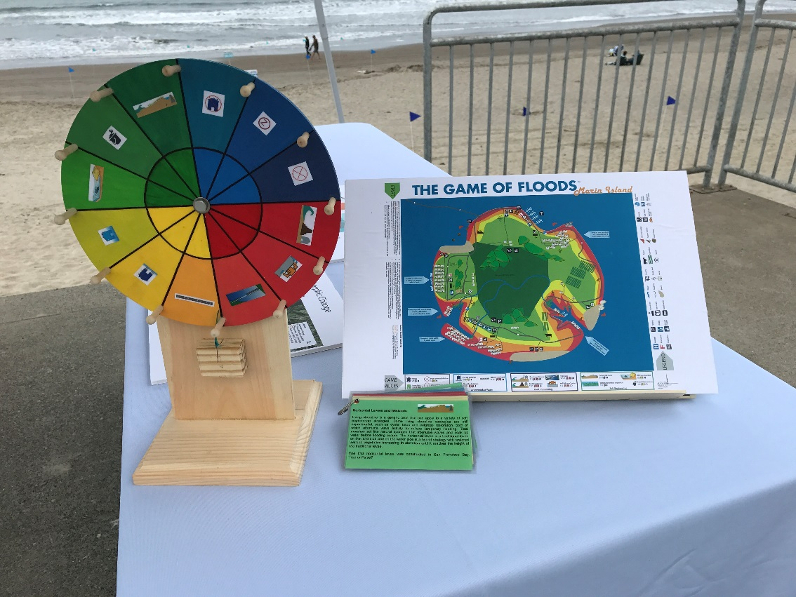
1. Make or buy a spinning game wheel.
2. Choose adaptation strategies, then copy and print the Game of Floods icons that are on the cards below. We organized strategies by color: blue = rules and regulations; red = hard engineering;
green = nature-based; and yellow = accommodation.
3. Develop questions for each strategy, similar to the cards below, and match them to the right color and icon.
4. Cut out the cards and laminate. Punch a hole in each card so they can be placed on a key ring or string.
5. When you’re at your event, have people spin the wheel and ask them a question for the icon on which they land. Offer a candy prize or something else that doesn’t end up in a landfill.

Typical wheel for purchase online.
Strategies can be written in or icons
can be printed as stickers.

Wheel of Floods Question Cards
Building Elevation  Raising structures on piles or piers may provide effective protection against temporary flooding, but may not effectively protect against permanent sea level rise. It may also allow communities to remain in place longer.  Can you think of a place where elevating a home might be a short-term strategy to address rising sea level? | Coastal Armoring 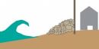  Coastal armoring refers to engineered solutions such as levees or seawalls that protect assets in place. Levees are common along the San Francisco Bay shoreline. Seawalls and other forms of hard shoreline armoring are more common along the ocean coastline. Armoring can have negative environmental impacts by blocking landward movement of beaches and accelerating shoreline erosion.  About 2% of the overall CA coastline is armored, including 10% of southern CA’s coastline. True or False?
Flood Proofing  Wet flood proofing allows floodwaters to enter an understory and be pumped out afterward. Dry flood proofing involves tightly sealing a building’s ducts, doors, windows and other openings. While flood proofing is not a solution to permanent sea level rise, in the near-term it allows communities to remain in place longer. The costs are low compared to other strategies, but they are born by the homeowners.  Buildings in the Marinship area use a combination of flood proofing methods, including floodwalls, temporary floodgates, waterproof paint, and pumps. True or False? | Tide Gates  Tide gates are engineered to prevent the flow of water upstream or inland. They can be engineered for extreme flooding events and could provide protection for long-term sea level rise. They pose potentially significant environmental impacts, including cutting off freshwater and salt water mixing and blocking migratory pathways for fish and wildlife.  The Delta Works is a series of construction projects in the Netherlands employing a combination of tide gates, dams, sluices, locks, and storm surge barriers. The storm surge barrier closes only when sea level is expected to rise 10 metres above MSL. True or False?
Elevating/Relocating Roads  Elevating or relocating roads may be necessary for the continued function of communities that they serve. Such infrastructure projects would likely be expensive. With proper mitigation of environmental impacts, they can be long-term solutions and ultimately can allow beaches and wetlands to move inland.  Can you think of roads in Marin County that flood regularly with high tides? | Zoning  Local governments can determine what is at risk, what is safe to build, and where it is safe to build. As an example, an “Accommodation Zone” could allow for continued development while requiring structures be sited and built to be more resilient to impacts. A “Conservation Zone” could be created to provide for gradual relocation of development in highly vulnerable areas.  Limiting development to low-density and low-intensity uses, such as agricultural, recreational, or open space uses is a regulation that could be used in a Conservation Zone. True or False?
Pump Station & Seawall  Pump stations are used to pump water out of streets and neighborhoods during flooding events. Used in tandom with seawalls or raised roads, they can effectively protect structures from flooding. But, they are expensive, they rely on electricity, and can be noisy and unsightly in a neighborhood environment.  The City of Miami Beach is embarking on a $500 million plan to install 80 pumps and raise roads and sidewalks across the city—a massive public works project that will take seven years total to complete. Pedestrians will step down two to three feet to reach the doors to buildings. True or False? | Post-Storm Building Restrictions  Local governments can determine where it is safe to build and regulate hazard areas to ensure that people and structures are out of harm’s way. In areas that are highly vulnerable and subject to repetitive impacts, regulations can restrict redevelopment of damaged structures.  Structures destroyed in New Orleans as a result of Hurricane Katrina were rebuilt in the same hazardous areas and to the same size that they existed prior to their destruction. True or False?
Living Shorelines  Living shoreline is a generic term that can apply to a variety of soft engineering strategies that rely on natural processes to attenuate waves and absorb water. Living shoreline strategies include oyster beds, eelgrass, and tidal marsh restoration. The horizontal levee is a traditional levee on the land side and on the water side is a hybrid strategy with wetland vegetation increasing in elevation until it reaches the height of the traditional levee.  The first horizontal levee was constructed in San Francisco Bay.  True or False? | Offshore Structures  Offshore structures can include barrier islands or artificial reefs. These can be expensive, but can break up wave energy to minimize erosion and temporary flooding while providing habitat benefits. Once submerged with rising waters, they lose their effectiveness.  Offshore structures could be used to effectively reduce bluff erosion along beaches backed by bluffs. True or False?
Managed Retreat/Relocation  Managed retreat can include demolishing or relocating buildings, abandoning efforts to control flooding and erosion, and enacting policy and zoning changes to restrict new development in hazardous areas. It can be expensive and can break up community fabric. However, it can be a long-term solution, ensure future development is done in safer areas, and allow the natural inland movement of natural resources such as beaches and marshes.  The US has a Hazard Mitigation Grant Program to assist homeowners who are relocating from hazardous areas. True or False? | Beach Nourishment & Dune Restoration  One of the major impacts of sea level rise is erosion of our beaches. Beach nourishment uses sand from other sources to replace that which has eroded and must be repeated periodically. Coastal dune restoration provides a buffer against extreme tides and storm surges. When restored with native plants, dunes are stabilized and continue providing valuable habitat.  The cost estimate of beach nourishment on the tiny coast of Delaware is $5 million per decade. True or False?
Building Elevation  Can you think of a place where elevating a home might be a short-term strategy to address rising sea level?  Stinson Beach in the Calles and Patios  Along the shoreline of Tomales Bay  Along the shoreline of Corte Madera Creek | Coastal Armoring  About 2% of the overall CA coastline is armored, including 10% of southern CA’s coastline.  False  About 10% of the overall CA coastline is armored, including 33% of southern CA’s coastline.
Flood Proofing  Buildings in the Marinship area use a combination of flood proofing methods, including floodwalls, temporary floodgates, waterproof paint, and pumps.  True | Tide Gates  The Delta Works storm surge barrier in the Netherlands closes only when sea level is expected to rise 10 meters above MSL.  False  The barrier closes when sea level is expected to rise 3 meters above MSL
Elevating/Relocating Roads  Can you think of roads in Marin County that flood regularly with high tides?  The Shoreline Highway along Bolinas Lagoon  Manzanita Parking lot  Gate 5 Road, Sausalito  Redwood Highway, Corte Madera  Highway 37 | Zoning  Limiting development to low-density and low-intensity uses, such as agricultural, recreational, or open space uses is a regulation that could be used in a Conservation Zone.  True
Pump Station & Seawall  The City of Miami Beach is embarking on a $500 million plan to install 80 pumps and raise roads and sidewalks across the city—a massive public works project that will take seven years total to complete. Pedestrians will step down two to three feet to reach the doors to buildings.  True | Post-Storm Building Restrictions  Structures destroyed in New Orleans as a result of Hurricane Katrina were rebuilt in the same hazardous areas and to the same size that they existed prior to their destruction.  True  Many structures were rebuilt, but not all. Retaining communities and sense of place is important and difficult to juxtapose with public safety.
Living Shorelines  The first horizontal levee was constructed in San Francisco Bay.  True  The levee is located south of the Oakland Airport on the San Lorenzo shoreline and includes the full spectrum of subtidal, marsh, and upland habitat. | Offshore Structures  Offshore structures could be used to effectively reduce bluff erosion along beaches backed by bluffs.  True
Managed Retreat/Relocation  The US has a Hazard Mitigation Grant Program to assist homeowners who are relocating from hazardous areas.  True  Between 1993 – 2011, 36,707 properties were purchased through the HMGP. Those households were resettled. | Beach Nourishment & Dune Restoration  The cost estimate of beach nourishment on the tiny coast of Delaware is $5 million per decade.  False  It’s $15 million/decade

